Installation of
Muller Alegro Quad-Creaser
Product Code: QC-MU/ALE-FP-6
48mm Shafts with 96mm Outer Diameter Creasing Unit
with 6mm Fixed Hinge Creasing Width
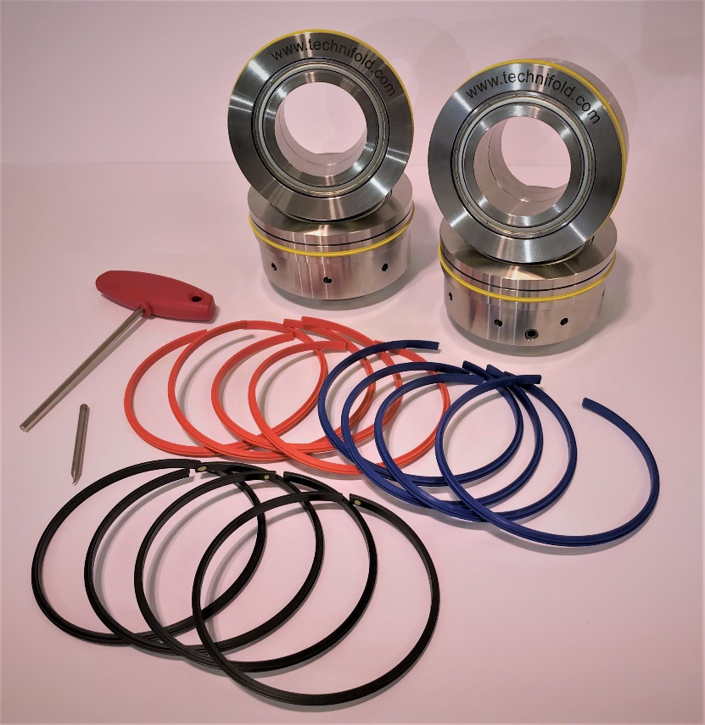
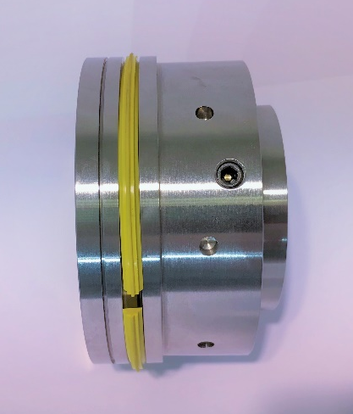
Unscrewing the 1x 8mm screw will allow the collar and mandrel parts to be separated and the Split Gripper Creasing Ribs to be removed or installed.

REMOVING AND REPLACING THE CREASING RIBS
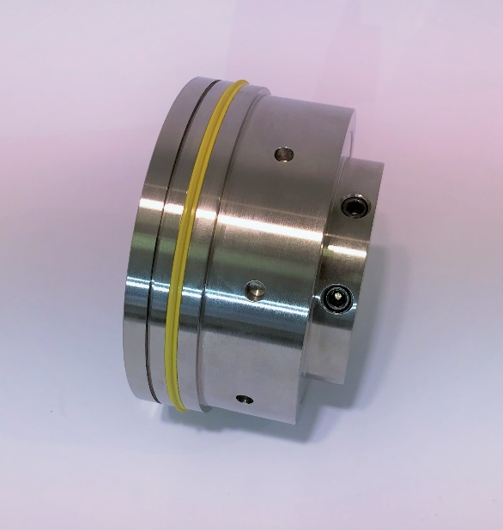
Tighten the 2x 8mm shaft locking screws to secure the creasing unit into position.
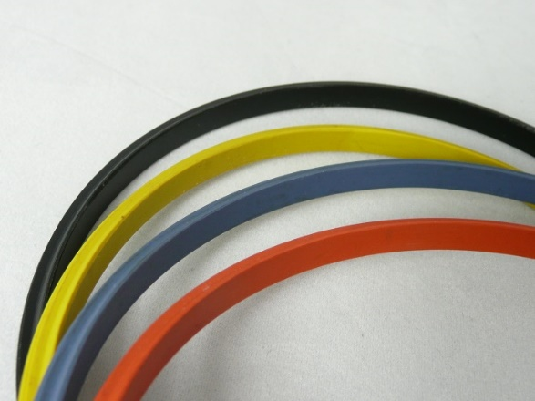
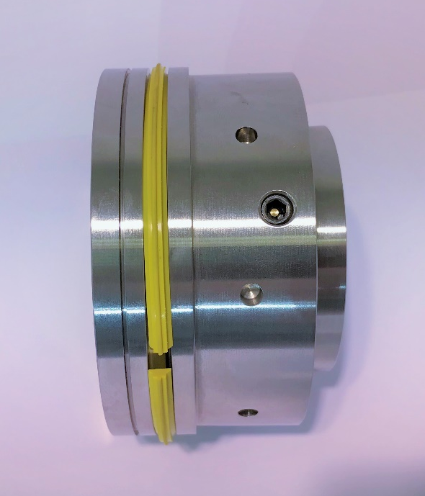
Rubber Creasing Rib Options
Orange – to crease thin cover stocks
Blue – to crease medium cover stocks
Yellow – to crease heavy cover stocks
Plastic Creasing Rib Options
Black (with Yellow Dot) – to crease heavy or laminate cover stocks where fibre-cracking is not an issue
All Colour Black – an (optional) extra-heavy crease setting for laminate cover stocks where fibre-cracking is not an issue
With the 1x 8mm inside screw loosened by a quarter-turn, unscrew the mandrel anti-clockwise apart until the gap is large enough to remove the creasing rib entirely.
To secure creasing rib screw shut the collar/mandrel by turning clockwise and re-tighten inside 8mm screw.
TOP AND BOTTOM COMPONENT CONFIGURATION & INSTALLATION
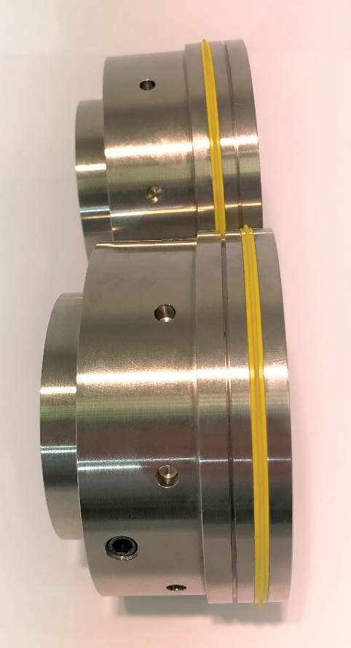
PLEASE NOTE: Before removing the existing scoring wheels from the machine, first mark the scoring position which is aligned to the clamp (the left-side spine position). Using a marker pen, or piece of tape, mark this point on the machine next to the scoring tool.
When installed within the machine, your Tech-ni-Fold top and bottom components will be configured as shown, with the male creasing rib and corresponding female channel aligned.
Install the first BOTTOM SHAFT creasing unit by aligning the left-side spine crease to the correct position using your clamp alignment mark and tighten the shaft fixing screws.
Slowly lower the top shaft creasing unit to make sure the protrusion of the creasing rib locates into the female channel of the bottom creaser unit.
Repeat the procedure for the next shaft.
DO NOT TIGHTEN THE TOP SHAFT FIXING SCREWS (see below).

Slowly run a 300gsm sheet of cover stock through the Quad Creaser units by hand.
As the cover travels through the crease units, the top crease units will automatically centralise to the optimum crease position. With the cover stock still in-between the upper and lower crease units now tighten the upper crease unit/top shaft locking screws.
ACHIEVING OPTIMAL CREASE CENTRALISATION

TOP SHAFT COMPONENTS
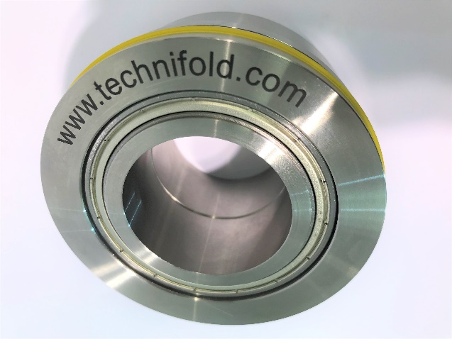
All components are supplied with bearings located in the inside bore.
Using the 8mm fixing screw the Top Shaft Creasing Components can be fixed to the shaft for production once centralised.
If the creasing ribs open-up during production, loosen the fixing screws on the top crease units to allow the creasing units to rotate freely on their in-built bearings.

When setting for different weights of stock simply insert the correct stock into the calliper blocks and the shafts will automatically be set to the correct pressure.
SETTING AND ADJUSTING SHAFT PRESSURES

The machine is now ready to test.

